

NOVAC TECHNOLOGY SOLUTIONS

User Manual

Document Version No.: 1.00

Revision History
Version No | Reason For Changes | Author | Approver
0.01 | Draft | Anurag Kumar
1.00 | Reviewed & Approved the User Manual | Anurag Kumar | NIJANTHAN PL

Table of Contents
1. Introduction 4
2. Financial endorsement for CAR product 4

Introduction

The document is prepared to understand and build an application for Contractor All Risk Insurance.

Financial endorsement for CAR product

Endorsement refers to any amendment or change effected to a live insurance policy. It is imperative that the policy has to be active or live in status for the endorsement to be effected. The endorsement can be made effective from endorsement request date, the calculation to be effected either annually or pro-rata wise accordingly.

Path: Engineering Endorsement -> Engineering Endorsement Financial
Screen Code: S0549

After enter the Policy number on clicking Go button, system will display the list of financial endorsements that are applicable for CAR policy.

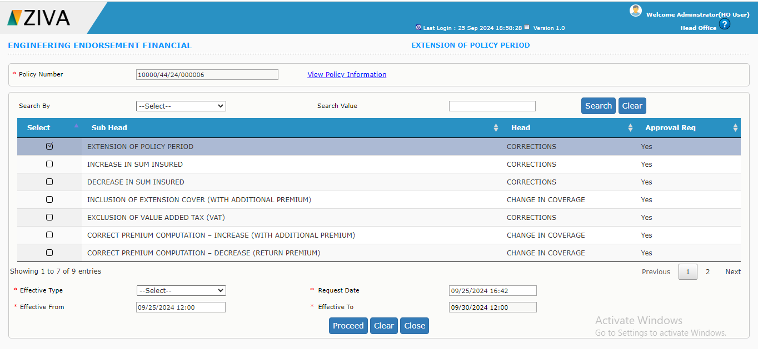

After selecting the respective checkbox against the endorsement click on Proceed button. After doing the changes in endorsement screen, click on Save button.

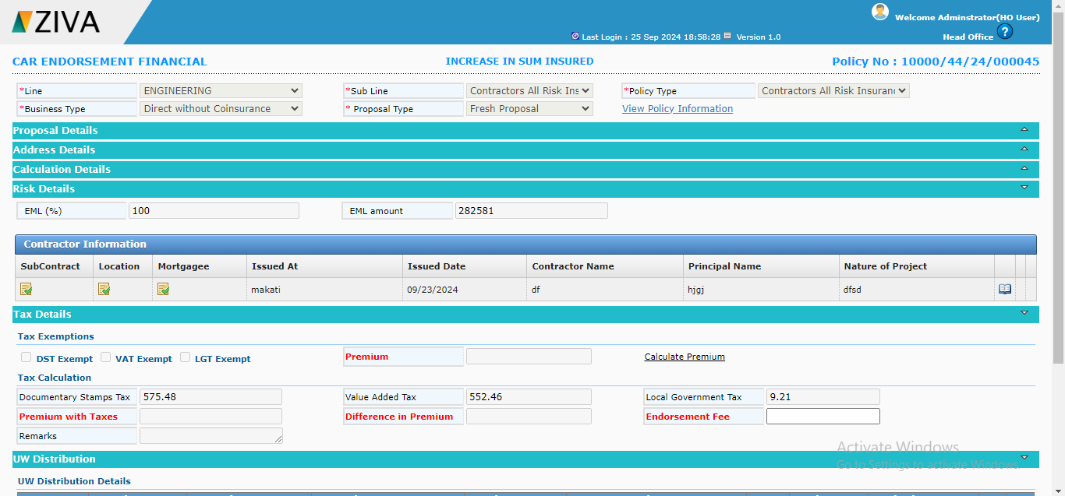

Increase the sum insured.

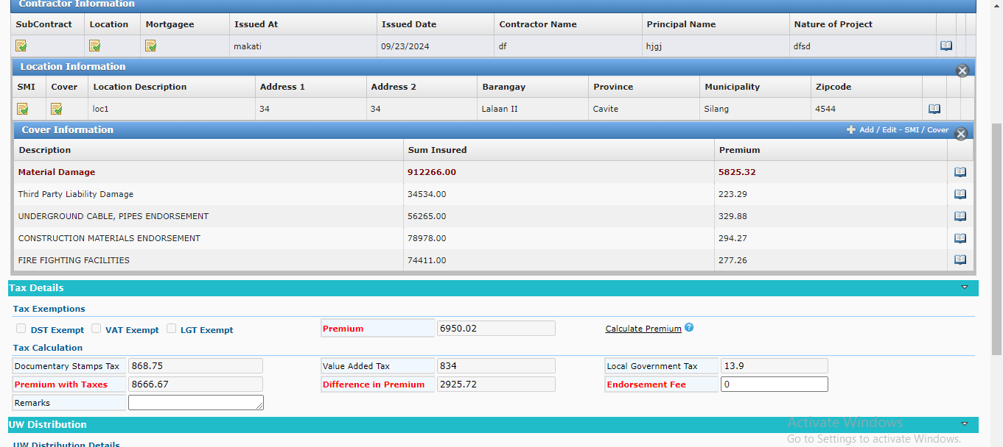

Now Click on submit button.

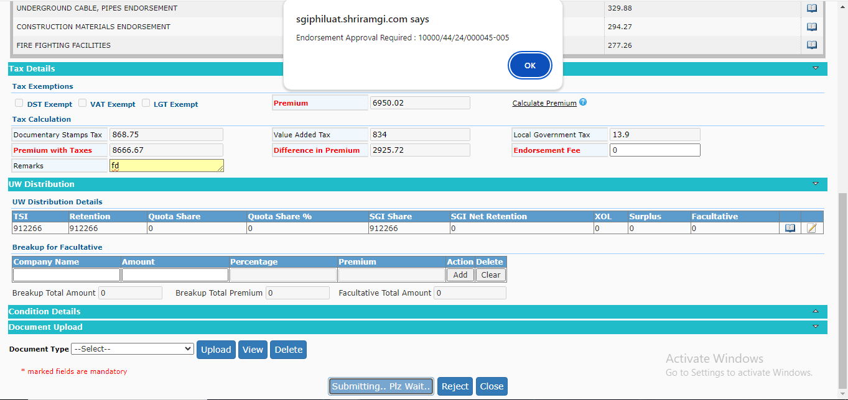
Endorsement is saved and endorsement no will be generated. Then user has to approve that record in endorsement approval screen.

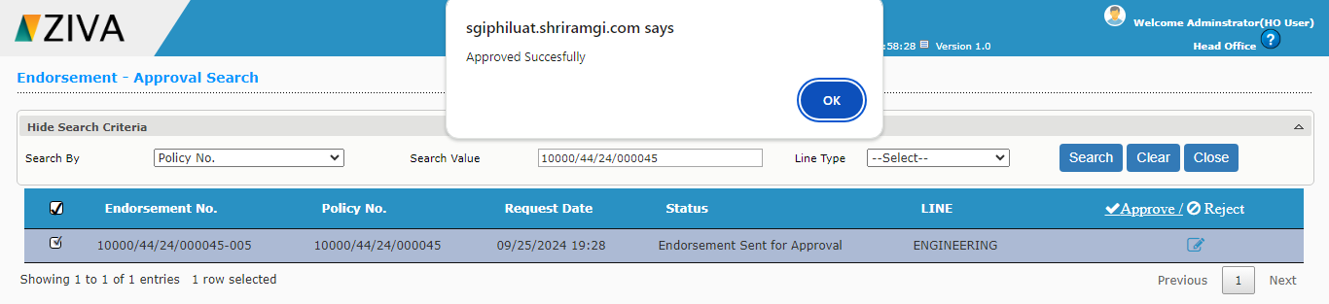
Then go to Endorsement confirmation screen and search the endorsement and click on edit button.
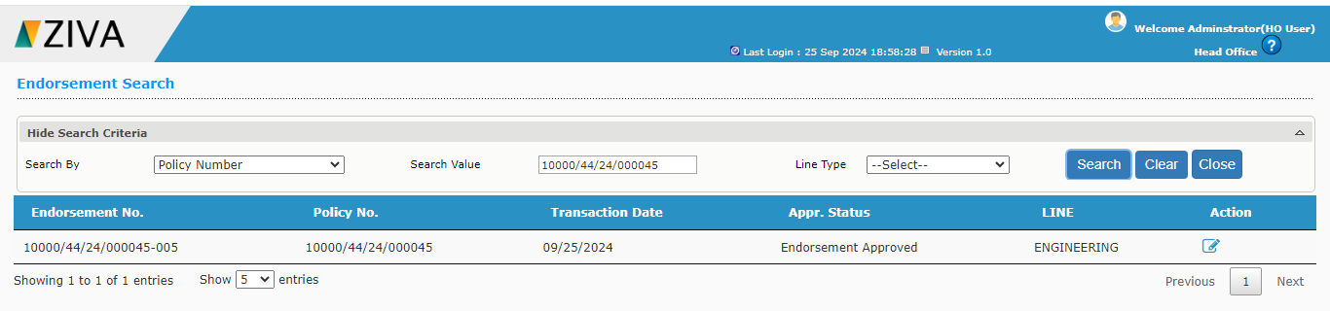

Then in confirmation screen, submit the record.
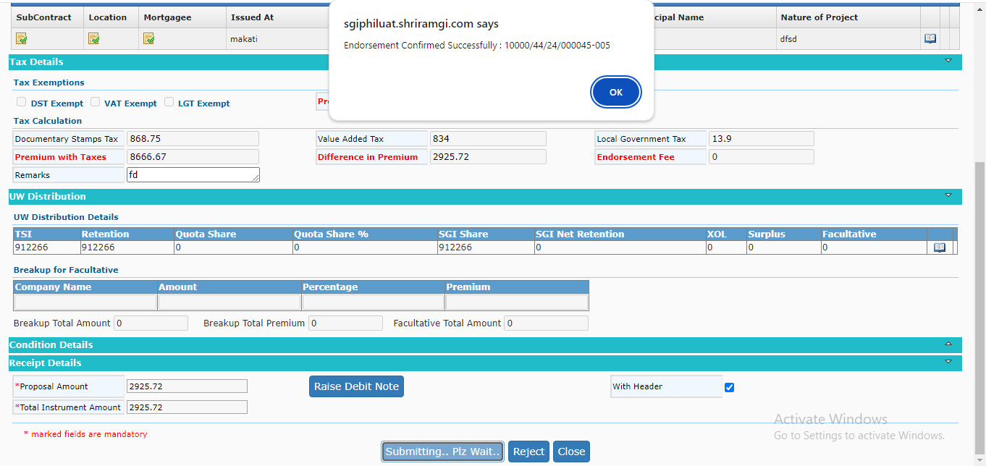

Once submit the record, download schedule button will be enabled. By clicking, the button user can able to download the endorsement schedule.

